*Christoph F. Eick*

Deadlines: Task 6: Thursday, May 5

15. Using a Belief Network Tool (25 points) Nathan

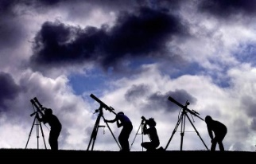

Fig. 2: Four Astronomers Looking at the Sky

**Assumption:**

Assume we have 4 astronomers in different parts of the world who make measurements M1, M2, M3 and M4 of the number[1] of stars N in some region of the sky. We have,

* **N <= 5,**
* **astronomers do not know that M1, M2, M3, and M4 are therefore limited to values 0 through 6**

**Assuming the astronomer’s telescope is not out of focus:**

* there is a probability of 0.05 that the astronomer counts a single star twice
  + overcounts by one star,
  + you can assume that the four astronomers never undercount,
  + moreover, if there is no star visible (N=0) the astronomer never overcounts.
* there is a 10% probability (P(Fi=1) = 0.1 for i=1,2,3,4) that a telescope is out of focus
* this is represented using random variables F1, F2, F3, and F4 - in which the astronomer undercounts by 3 or more stars, e.g.,
  + if N is 4 and the astronomer’s telescope is out of focus, the astronomer will count 1 or 0 stars.
  + if N, on the other hand, is 2 an astronomer with an out of focus telescope will count 0 stars
* You can assume **if information is missing that each case has the same probability.**

**Task:**

* Design a belief network and compute the probability of the other variables assuming the following pieces of evidence are given,
* feel free to use *Netica (*<http://www.norsys.com/download.html> ) or any another belief network tool to compute your answer,
  + **NB:** Including the answer ‘inconsistent’ in the case that the evidence is inconsistent, e.g., the evidence N=1 M1=3 is inconsistent—as it is ‘impossible’, because astronomer1 never overcounts by more than 1 star!

1. M1=5 M2=4 M3=1
2. M1=4 M2=4 M3=0, M4=1
3. N=4, M2=1, M3=0
4. M1=0 M2=5 M3=5 M4=4
5. N=4 F1=0 F2=0 F3=1 F4=1
6. N=5
7. No evidence

Submit the complete Belief Network you created—including all its probability tables—, and the findings you obtained for the seven cases listed above!

1.